# **Functionalities and Screenshots**

## **Register:**

User has to enter his mobile number for OTP Verification.

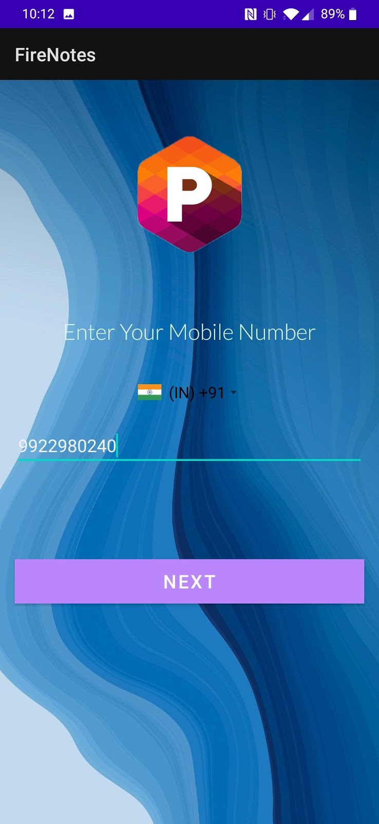                  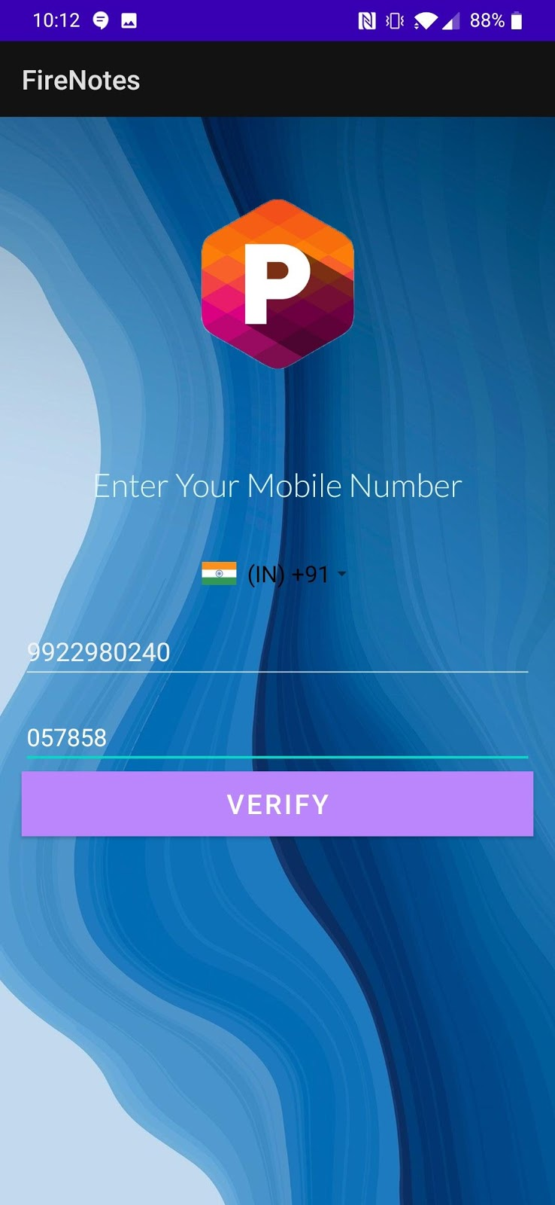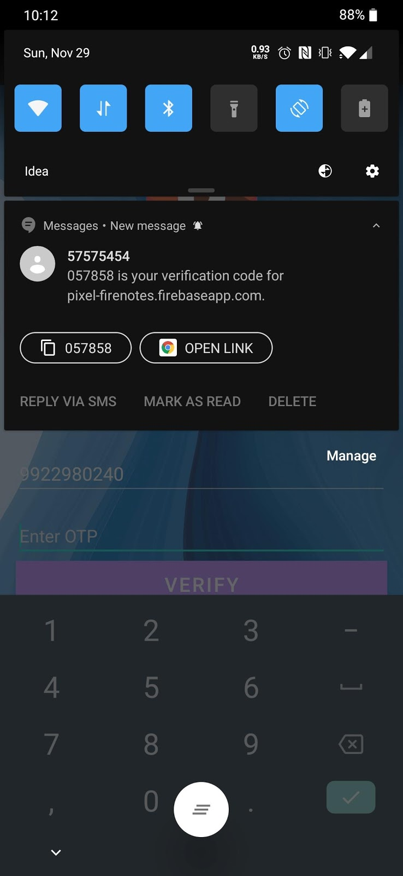                         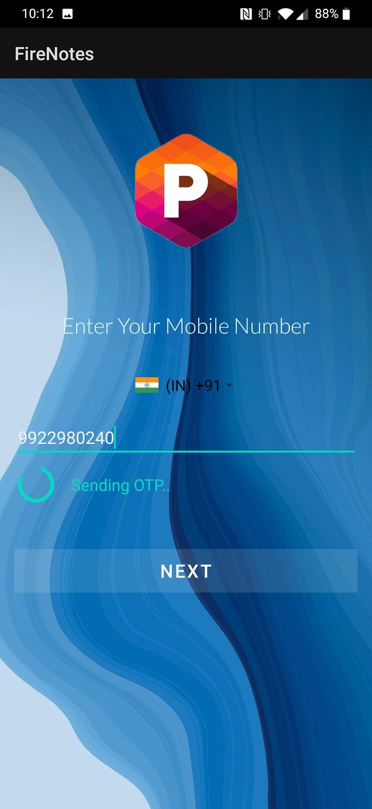

After the OTP Verification user is directed to a page which asks for First Name, Last Name and Email Address.

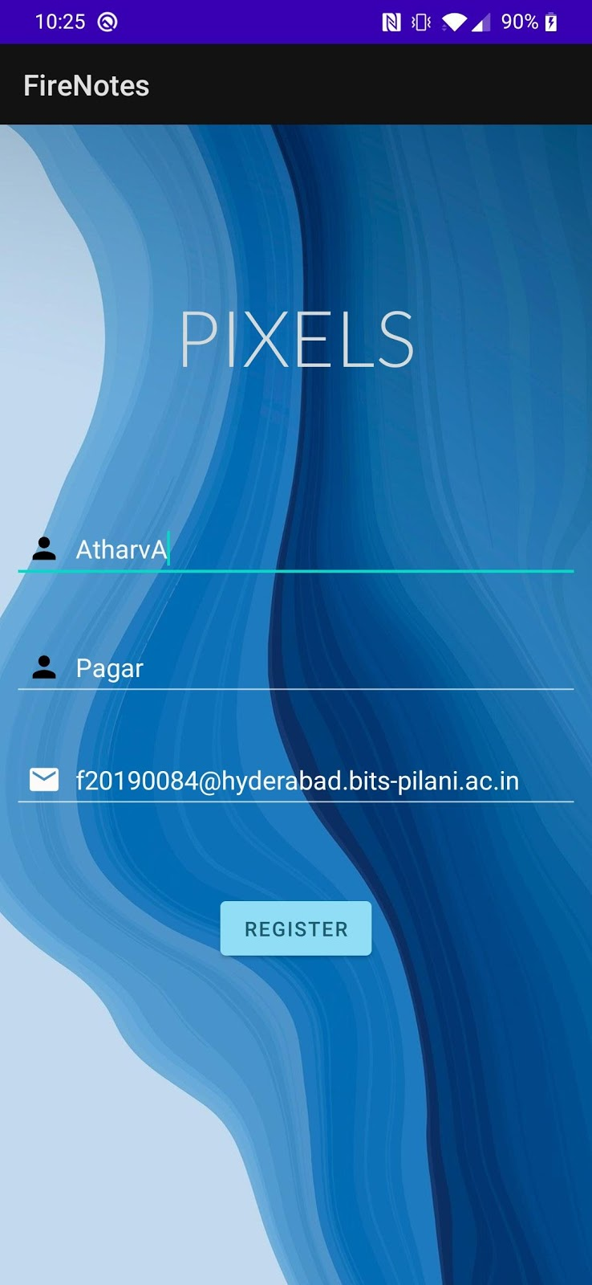

Once the user successfully logs in he is directed towards the MainActivity Area which consists of all the existing notes the user has created and options to add note and add an event using calendar.

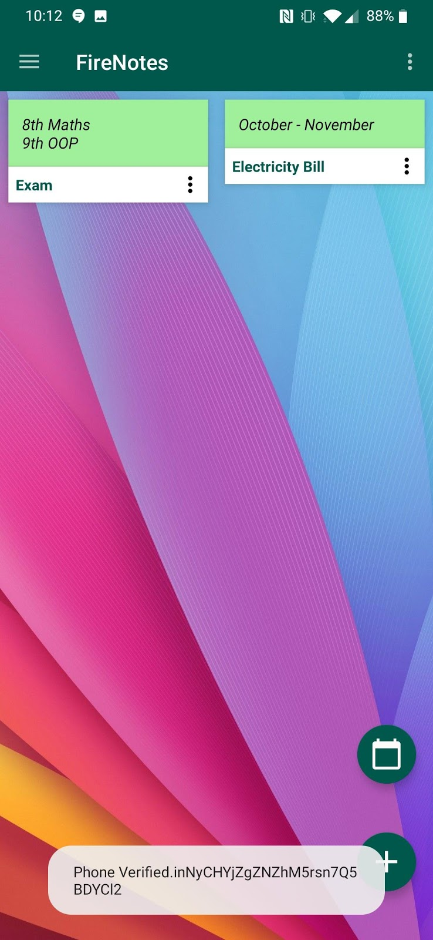

The notes that are being added can also be edited,deleted and  shared via mail, Whatsapp, Messages etc.

# **Options Available in MainActivityArea:**

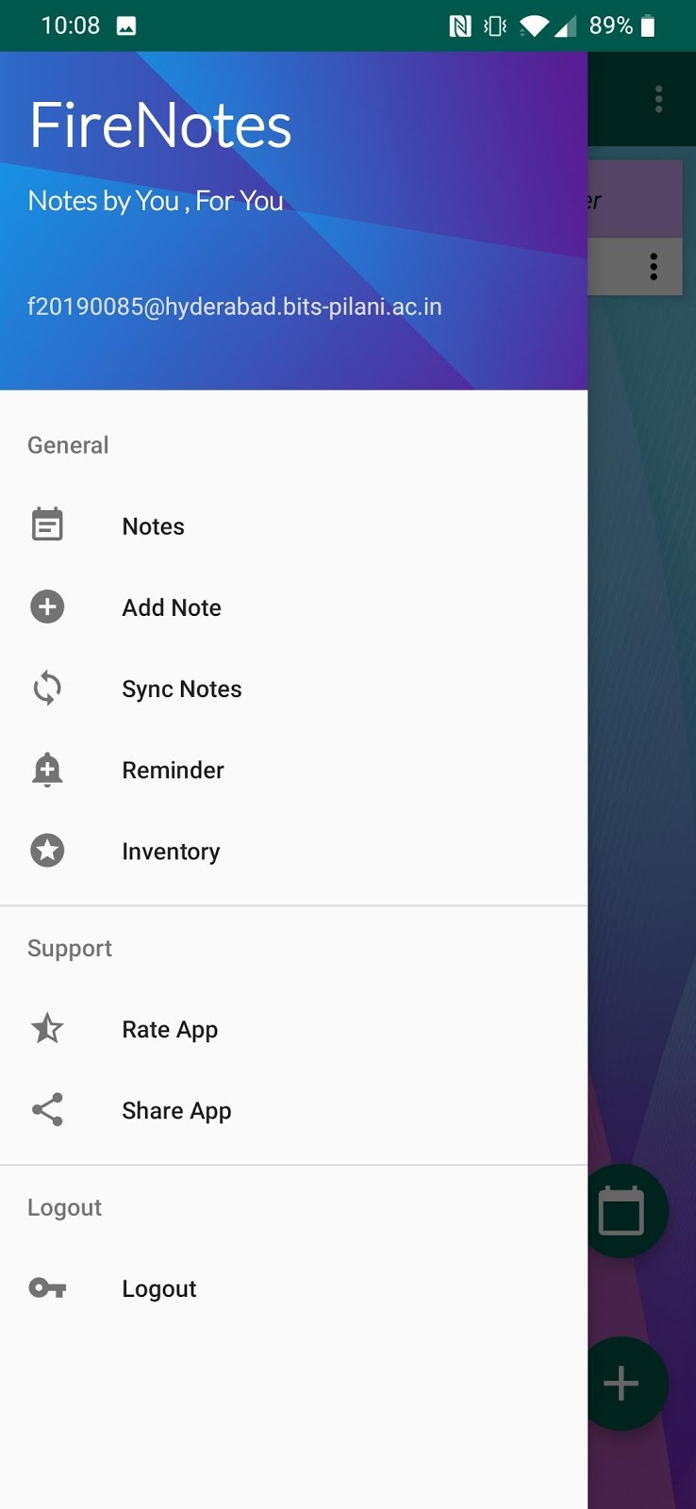

# **DashBoard:**

App provides predefined categories:

1.HouseHold

2.Work

3.Educational

4.Groceries

5.Stationary

6.Others

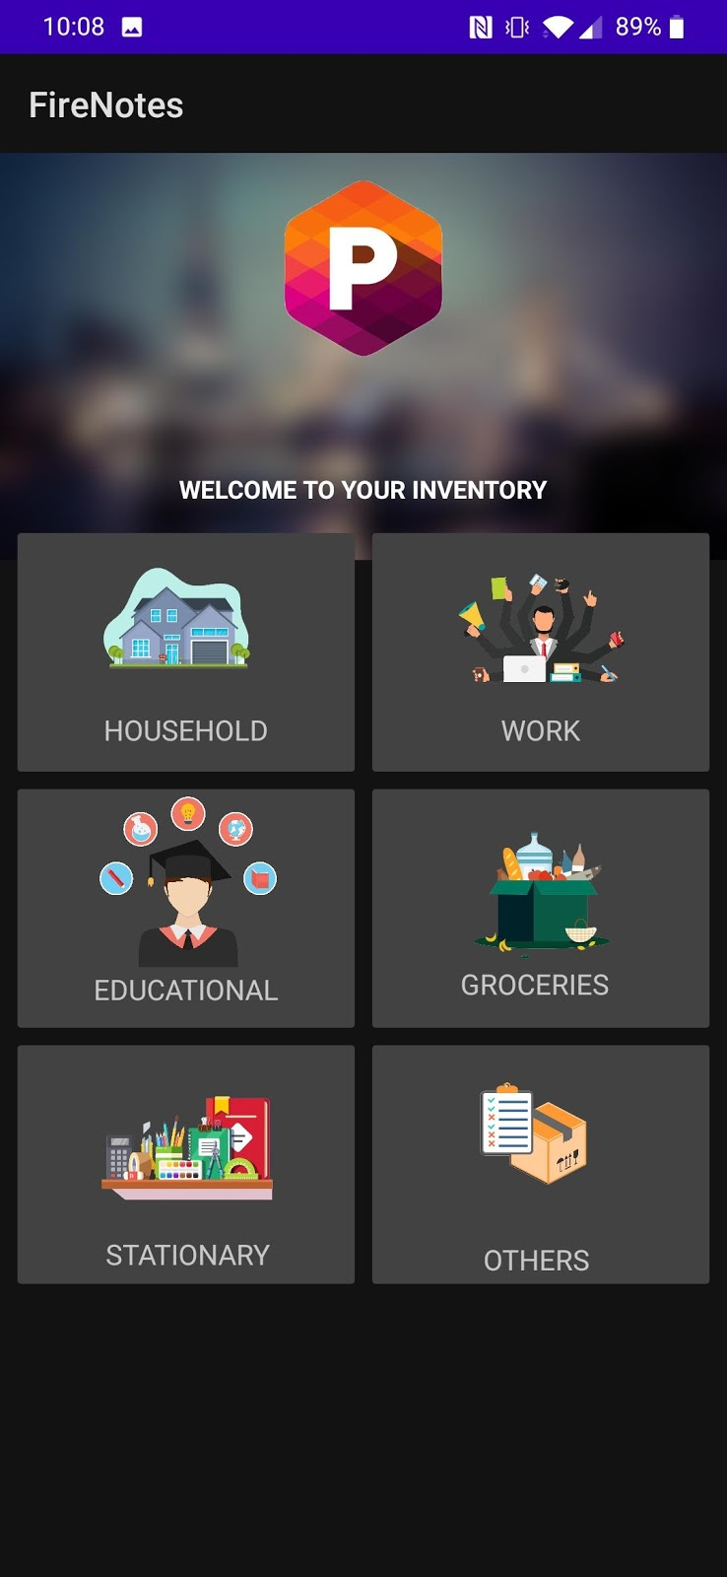                        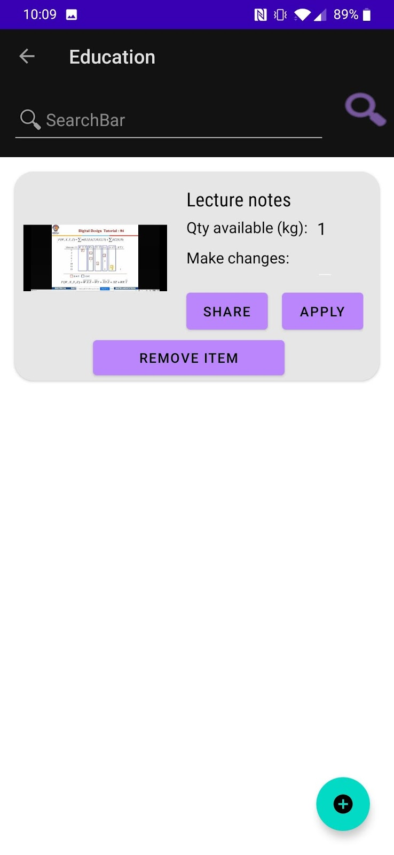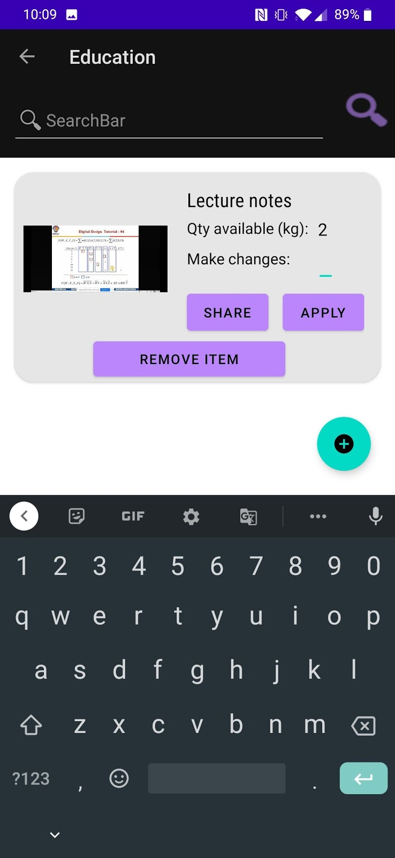                         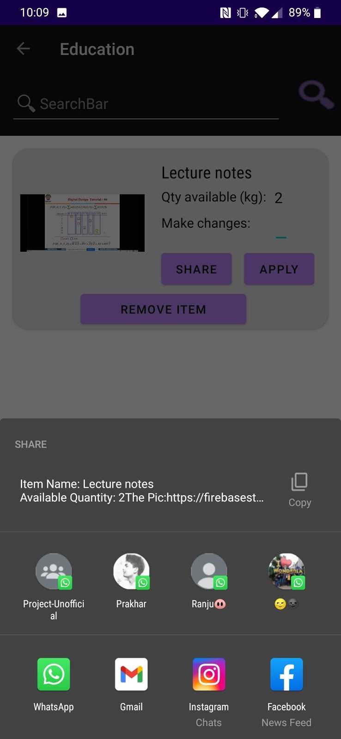

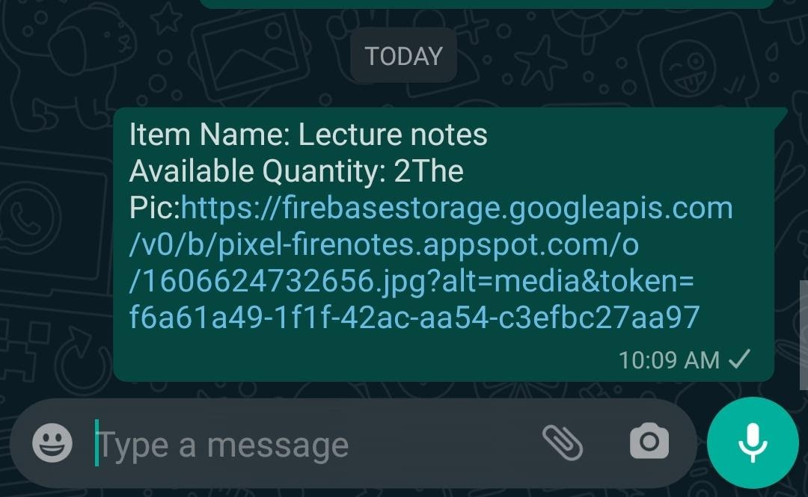

Users Data is also maintained in FireStore Database:

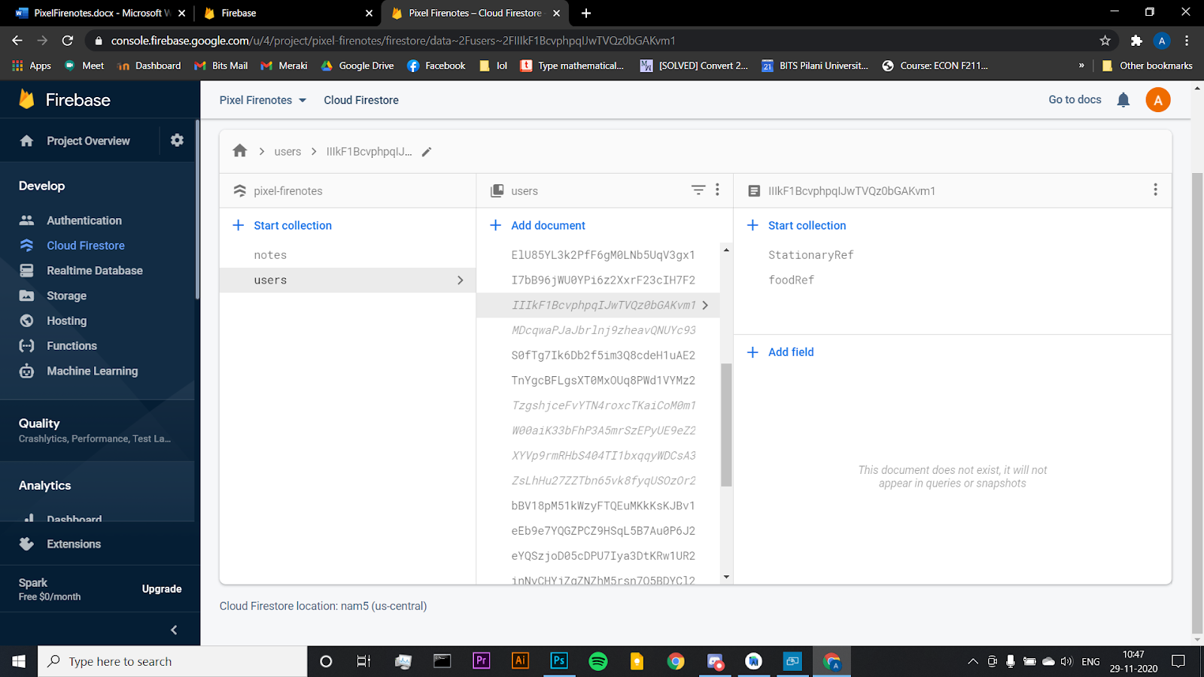

# **Inventory:**

The user can keep track of their items in the inventory by adding the quantities, images and even sharing it. It can update the current Number of items thus Making it a tracker

                        

# **Trigger:**

The user can schedule reminders for important tasks at a desired time.

They will be notified with a push notification even if the app is closed.

For Reminder user have the option to Set Date, Time, Repetition Interval and Type of Repetition.

                    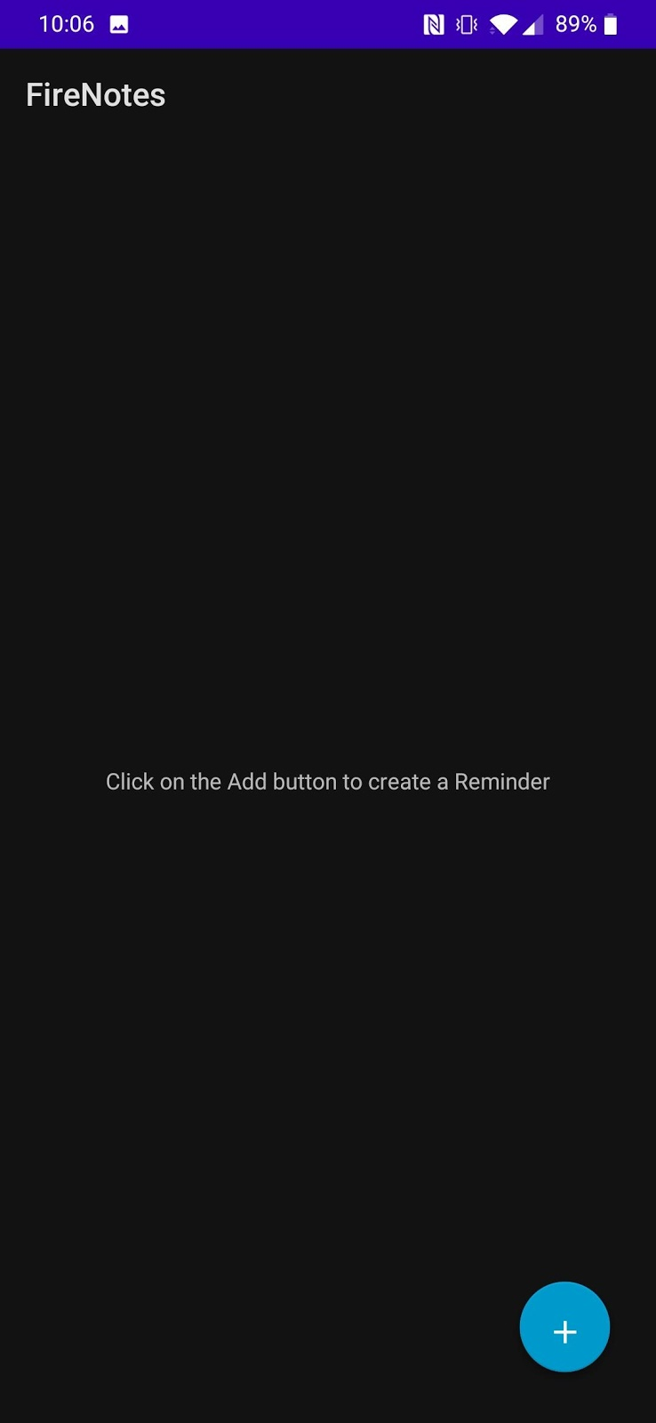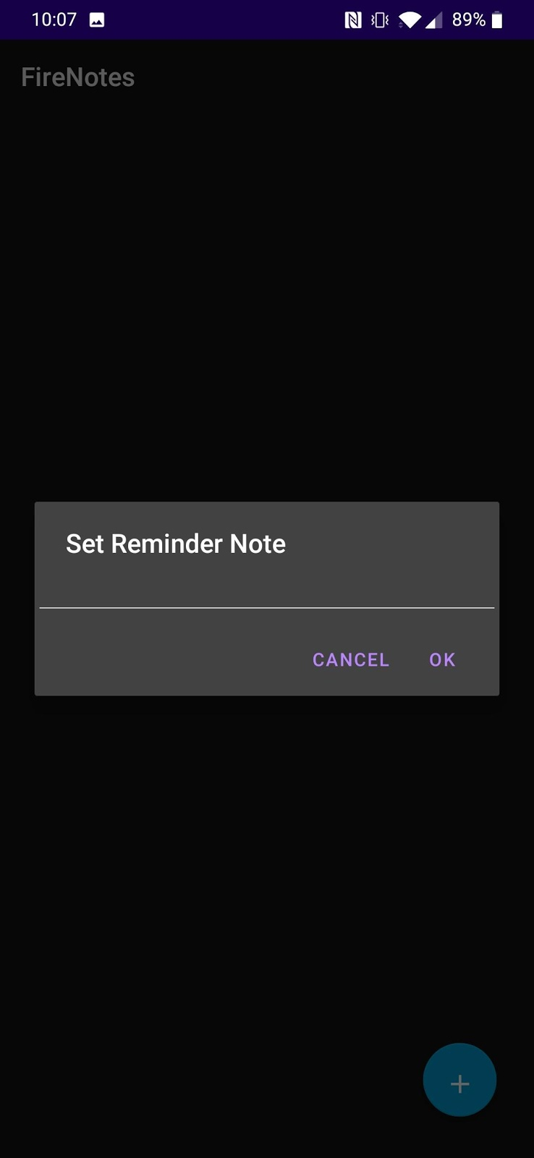                          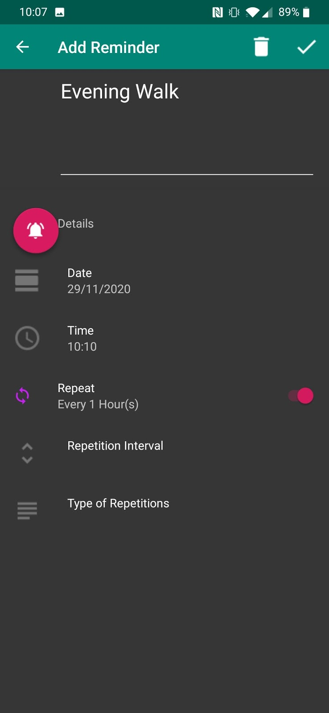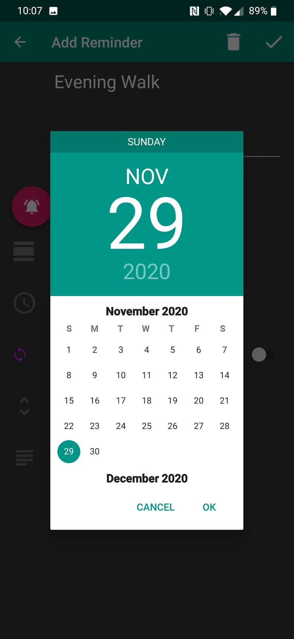                               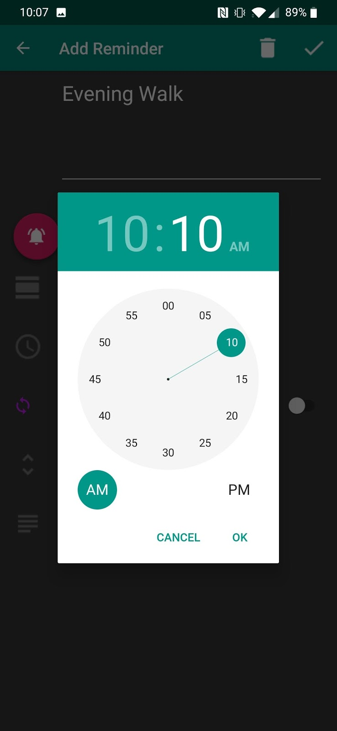

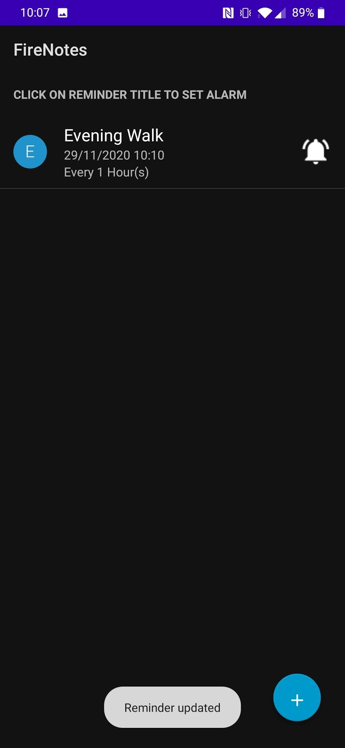

# **Rating the App:**

The feedback can be given by the user in Rate App Section

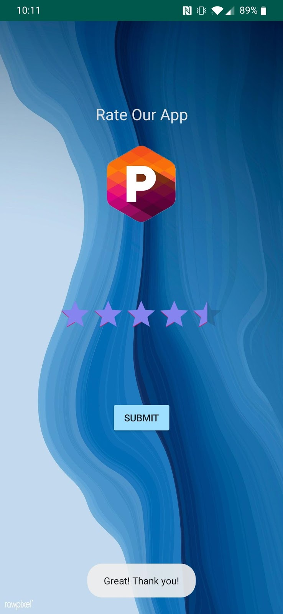

# **Extra Features:**

Add Calendar Event-





